**WORKSHEET-3.1**

**STUDENT’S NAME- SHUBHAM BAWANKAR**

**STUDENT’S UID- 20BCS7409**

**CLASS/GROUP-20CSE10/B**

**SEMESTER-2**

**SUBJUECT - IOT LAB**

**Task:**

**Design a wireless network signal strength logging system for IoT devices.**

**Apparatus:**

* **PC with Arduino**
* **Connecting Wires**
* **Breadboard**
* **DOIT ESP32 DEVKIT V1**
* **10uF Electrolytic Capacitor**
* **Wire Clipper**
* **USB Type A to Micro USB Cable**
* **DC 5V Power Supply**
* **DC 3.3V Power Supply**

**Screenshot-1**

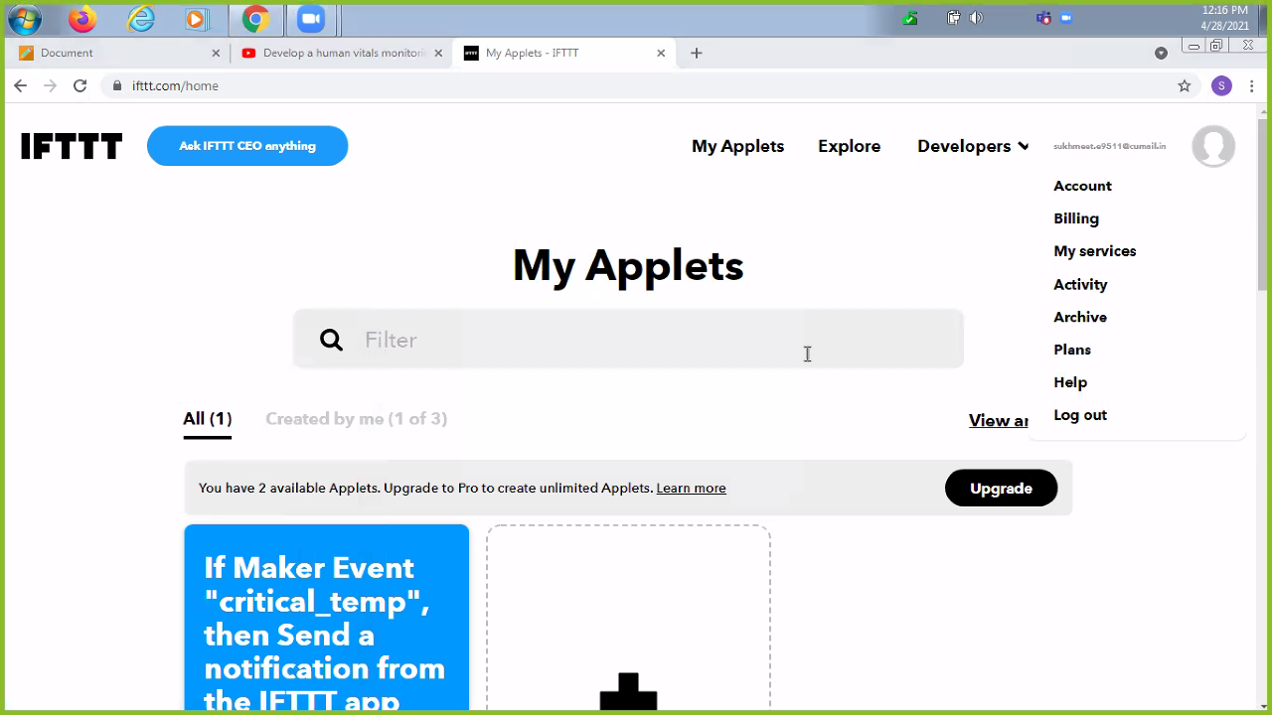

**Screenshot-2**

